Logarithmic Spiral
# Source: AI Source: Provided by: [Data Path: Persons Table -> ID Column: 1, Name_En Column: Motasem Essam] -> From: [ChatGPT] on [7/25/2026]
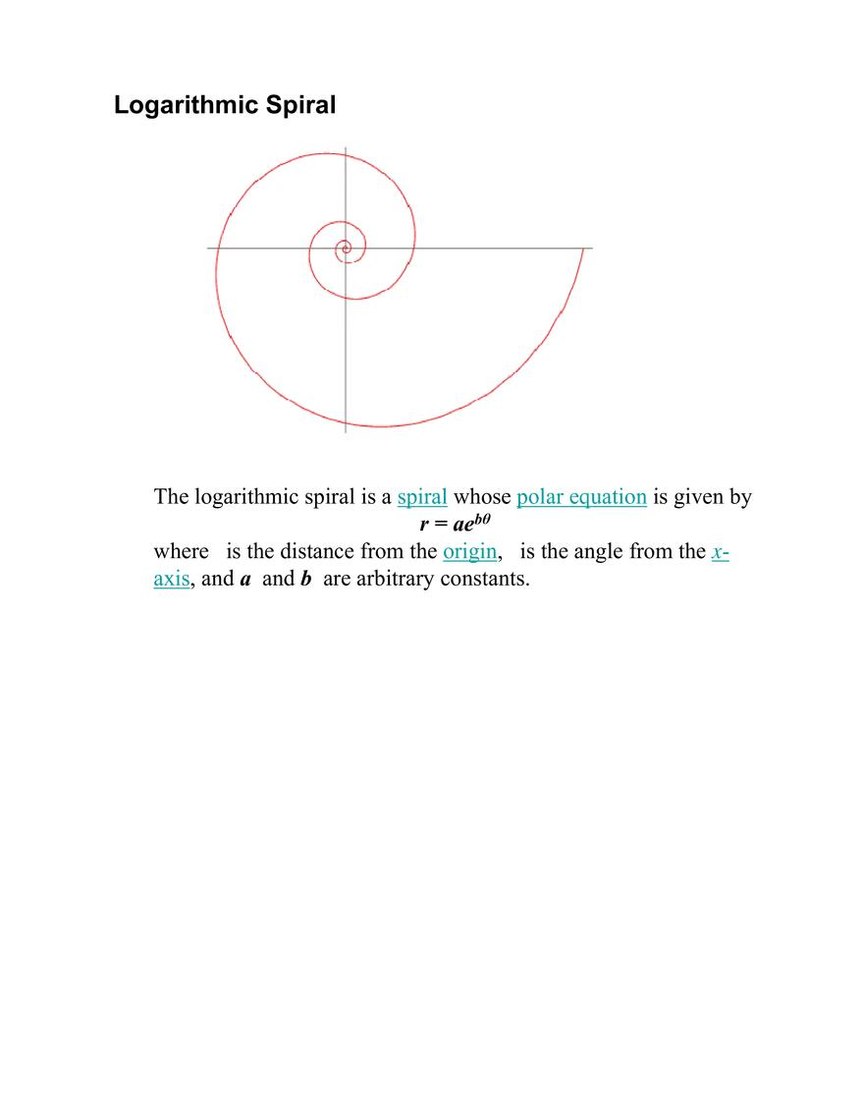
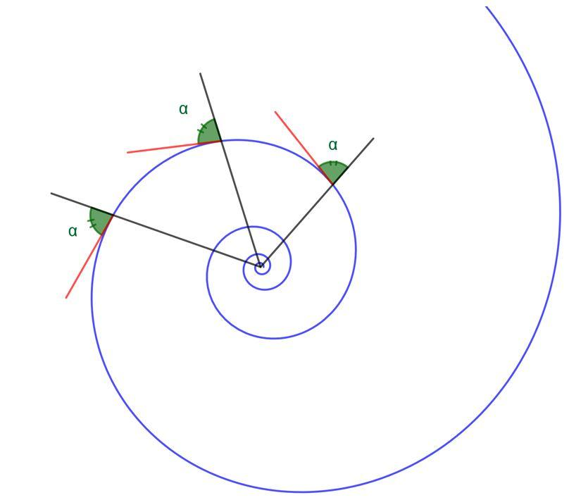
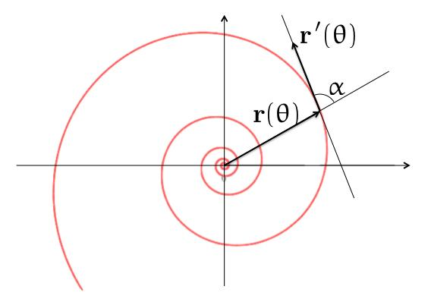
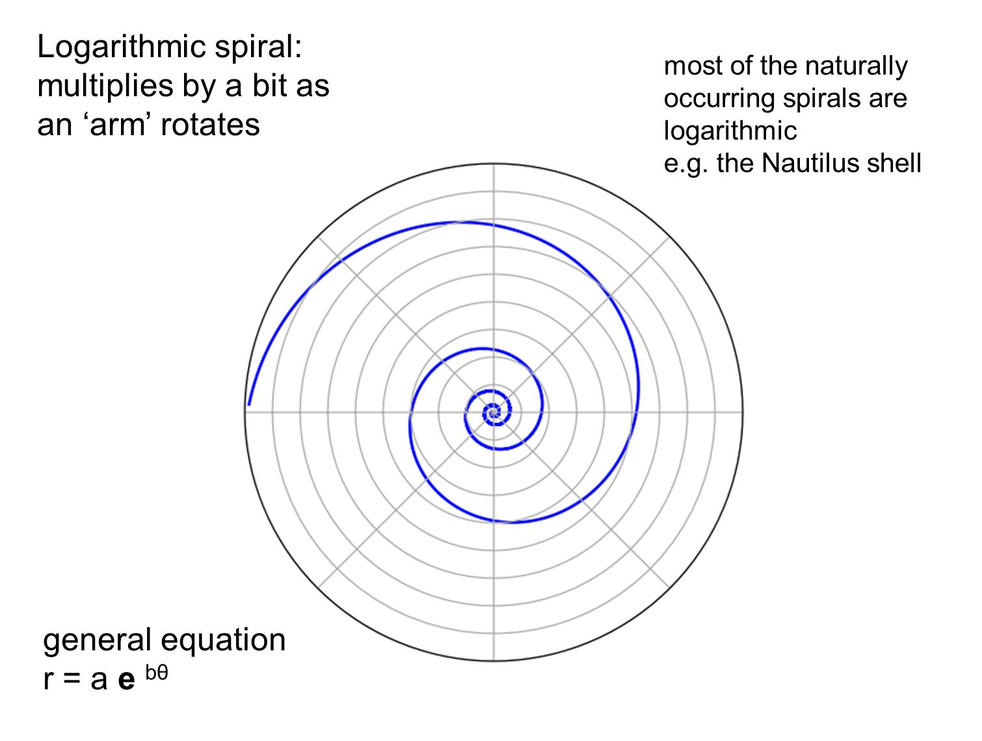
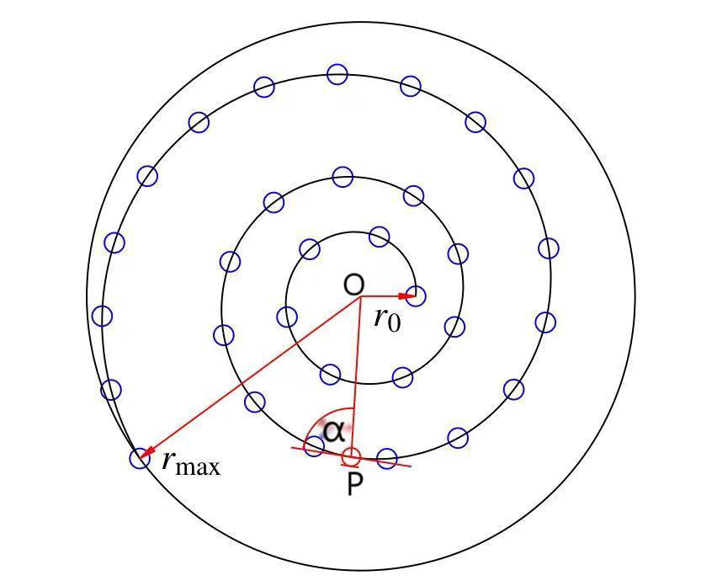
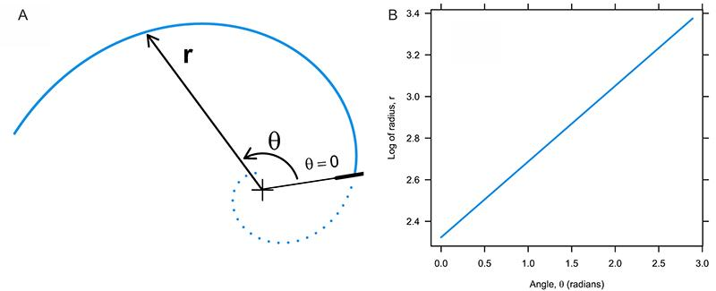

Definition
# Source: AI Source: Provided by: [Data Path: Persons Table -> ID Column: 1, Name_En Column: Motasem Essam] -> From: [ChatGPT] on [7/25/2026]
A Logarithmic Spiral is a spiral in which the radial distance from the center changes exponentially with the angle.
Its standard polar equation is:
$$\boxed{r=ae^{bθ}}$$
where:
- $r$= radial distance from the pole
- $θ$= angular position
- $a$= positive scaling constant
- $b$= growth or decay constant
The defining relationship is:
$$\boxed{\ln{r}=\ln{a}+bθ}$$
Thus, the logarithm of the radius changes linearly with the angle.

Fundamental Concept
# Source: AI Source: Provided by: [Data Path: Persons Table -> ID Column: 1, Name_En Column: Motasem Essam] -> From: [ChatGPT] on [7/25/2026]
Unlike an Archimedean Spiral, whose radius changes by a constant amount for equal angular intervals, a Logarithmic Spiral changes by a constant ratio.
For:
$$r=ae^{bθ}$$
if the angle increases by a fixed amount $Δθ$, then:
$$r\left(θ+Δθ\right)=ae^{b\left(θ+Δθ\right)} \\ =r\left(θ\right)e^{bΔθ}$$
Therefore:
$$\boxed{\frac{r\left(θ+Δθ\right)}{r\left(θ\right)}=e^{bΔθ}}$$
The radius is multiplied by the same factor for every equal angular interval.

Basic Structure
# Source: AI Source: Provided by: [Data Path: Persons Table -> ID Column: 1, Name_En Column: Motasem Essam] -> From: [ChatGPT] on [7/25/2026]
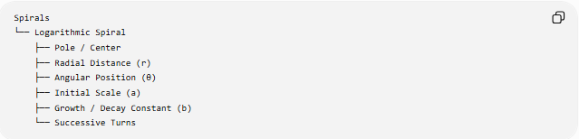
Spirals
└── Logarithmic Spiral
├── Pole / Center
├── Radial Distance (r)
├── Angular Position (θ)
├── Initial Scale (a)
├── Growth / Decay Constant (b)
└── Successive Turns
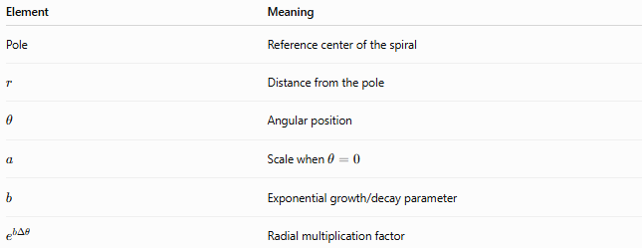
Element | Meaning
Pole | Reference center of the spiral
$$r$$ | Distance from the pole
$$θ$$ | Angular position
$$a$$ | Scale when $θ=0$
$$b$$ | Exponential growth/decay parameter
$$e^{bΔθ}$$ | Radial multiplication factor

Mathematical Representation
# Source: AI Source: Provided by: [Data Path: Persons Table -> ID Column: 1, Name_En Column: Motasem Essam] -> From: [ChatGPT] on [7/25/2026]
Standard Polar Equation
$$\boxed{r=ae^{bθ}}$$
where:
$$a>0$$
Logarithmic Form
Taking the natural logarithm:
$$\ln{r}=\ln{a}+bθ$$
Therefore:
$$\boxed{\ln{r}=\ln{a}+bθ}$$
This shows why the spiral is called logarithmic.
Parametric Equations
Using:
$$x=r\cos{θ}$$
and
$$y=r\sin{θ}$$
we obtain:
$$\boxed{x=ae^{bθ}\cos{θ}} \\ \boxed{y=ae^{bθ}\sin{θ}}$$

Radial Growth
# Source: AI Source: Provided by: [Data Path: Persons Table -> ID Column: 1, Name_En Column: Motasem Essam] -> From: [ChatGPT] on [7/25/2026]
Differentiate:
$$r=ae^{bθ}$$
with respect to $θ$:
$$\boxed{\frac{dr}{dθ}=be^{bθ}a}$$
Therefore:
$$\boxed{\frac{dr}{dθ}=br}$$
This means the rate of radial change is proportional to the current radius.
This is a fundamental characteristic of the Logarithmic Spiral.

Outward and Inward Logarithmic Spirals
# Source: AI Source: Provided by: [Data Path: Persons Table -> ID Column: 1, Name_En Column: Motasem Essam] -> From: [ChatGPT] on [7/25/2026]
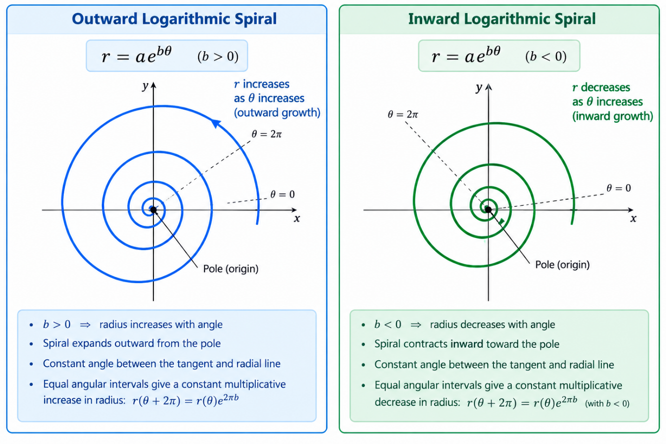

Outward Logarithmic Spiral
# Source: AI Source: Provided by: [Data Path: Persons Table -> ID Column: 1, Name_En Column: Motasem Essam] -> From: [ChatGPT] on [7/25/2026]
If:
$$b>0$$
then:
$$\frac{dr}{dθ}>0$$
and the radius increases as $θ$increases.
Thus, the spiral expands outward.

Inward Logarithmic Spiral
# Source: AI Source: Provided by: [Data Path: Persons Table -> ID Column: 1, Name_En Column: Motasem Essam] -> From: [ChatGPT] on [7/25/2026]
If:
$$b<0$$
then:
$$\frac{dr}{dθ}<0$$
and the radius decreases as $θ$increases.
Thus, the spiral contracts inward.

Equiangular Property
# Source: AI Source: Provided by: [Data Path: Persons Table -> ID Column: 1, Name_En Column: Motasem Essam] -> From: [ChatGPT] on [7/25/2026]
One of the most important properties of the Logarithmic Spiral is that it is an equiangular spiral.
The angle between the tangent to the spiral and the radial direction is constant.
If this constant angle is denoted by $α$, then:
$$\boxed{\tan{α}=\frac{r}{dr/dθ}}$$
Since:
$$\frac{dr}{dθ}=br$$
we obtain:
$$\tan{α}=\frac{r}{br}$$
Therefore:
$$\boxed{\tan{α}=\frac{1}{b}}$$
or:
$$\boxed{α=\arctan\left(\frac{1}{b}\right)}$$
for the corresponding orientation convention.
Thus, the angle does not change as the curve winds around the pole.

8. Constant Growth Ratio
# Source: AI Source: Provided by: [Data Path: Persons Table -> ID Column: 1, Name_En Column: Motasem Essam] -> From: [ChatGPT] on [7/25/2026]
Suppose the angle increases by one complete revolution:
$$Δθ=2π$$
Then:
$$r\left(θ+2π\right)=r\left(θ\right)e^{2πb}$$
Therefore:
$$\boxed{\frac{r\left(θ+2π\right)}{r\left(θ\right)}=e^{2πb}}$$
Every complete turn multiplies the radius by the same factor.
This is fundamentally different from the Archimedean Spiral.

Logarithmic Spiral vs Archimedean Spiral
# Source: AI Source: Provided by: [Data Path: Persons Table -> ID Column: 1, Name_En Column: Motasem Essam] -> From: [ChatGPT] on [7/25/2026]
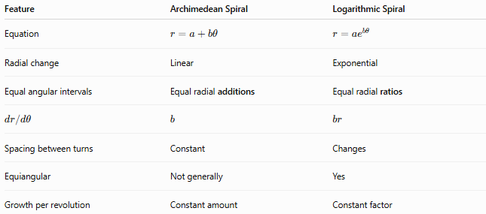
Feature | Archimedean Spiral | Logarithmic Spiral
Equation | $$r=a+bθ$$ | $$r=ae^{bθ}$$
Radial change | Linear | Exponential
Equal angular intervals | Equal radial additions | Equal radial ratios
$$dr/dθ$$ | $$b$$ | $$br$$
Spacing between turns | Constant | Changes
Equiangular | Not generally | Yes
Growth per revolution | Constant amount | Constant factor
The essential distinction is:
$$\boxed{\text{Archimedean: constant radial difference}} \\ \boxed{\text{Logarithmic: constant radial ratio}}$$

Number of Turns
# Source: AI Source: Provided by: [Data Path: Persons Table -> ID Column: 1, Name_En Column: Motasem Essam] -> From: [ChatGPT] on [7/25/2026]
The number of complete turns over an angular interval $Δθ$is:
$$\boxed{N=\frac{Δθ}{2π}}$$
After $N$complete turns:
$$θ→θ+2πN$$
and therefore:
$$r_{\text{new}}=r_{\text{old}}e^{2πbN}$$
Thus:
$$\boxed{\frac{r_{\text{new}}}{r_{\text{old}}}=e^{2πbN}}$$

Arc Length
# Source: AI Source: Provided by: [Data Path: Persons Table -> ID Column: 1, Name_En Column: Motasem Essam] -> From: [ChatGPT] on [7/25/2026]
For a polar curve:
$$L=\int_{θ_{1}}^{θ_{2}}{\sqrt{r^{2}+{\left(\frac{dr}{dθ}\right)}^{2}}} dθ$$
For the Logarithmic Spiral:
$$r=ae^{bθ}$$
and:
$$\frac{dr}{dθ}=br$$
Therefore:
$$L=\int_{θ_{1}}^{θ_{2}}{r}\sqrt{1+b^{2}} dθ$$
so:
$$\boxed{L=a\sqrt{1+b^{2}}\int_{θ_{1}}^{θ_{2}}{e^{bθ}} dθ}$$
For $b≠0$:
$$\boxed{L=\frac{a\sqrt{1+b^{2}}}{b}\left(e^{bθ_{2}}-e^{bθ_{1}}\right)}$$
For an appropriate orientation and $b<0$, the expression can equivalently be written with absolute values to ensure positive length.

Area Swept by the Spiral
# Source: AI Source: Provided by: [Data Path: Persons Table -> ID Column: 1, Name_En Column: Motasem Essam] -> From: [ChatGPT] on [7/25/2026]
For a polar curve:
$$A=\frac{1}{2}\int_{θ_{1}}^{θ_{2}}{r^{2}} dθ$$
Substituting:
$$r=ae^{bθ}$$
gives:
$$A=\frac{1}{2}\int_{θ_{1}}^{θ_{2}}{a^{2}}e^{2bθ} dθ$$
For $b≠0$:
$$\boxed{A=\frac{a^{2}}{4b}\left(e^{2bθ_{2}}-e^{2bθ_{1}}\right)}$$
with the sign interpreted according to the chosen orientation of the angular interval.

Example
# Source: AI Source: Provided by: [Data Path: Persons Table -> ID Column: 1, Name_En Column: Motasem Essam] -> From: [ChatGPT] on [7/25/2026]
Consider:
$$\boxed{r=e^{0.1θ}}$$
Here:
$$a=1, b=0.1$$
At:
$$θ=0$$
we have:
$$r=1$$
After one complete revolution:
$$θ=2π$$
so:
$$r=e^{0.1\left(2π\right)} \\ \boxed{r=e^{0.2π}}$$
Therefore, the radius has been multiplied by:
$$\boxed{e^{0.2π}}$$
It does not increase by a fixed amount; it increases by a fixed multiplicative factor for each complete revolution.

Golden Spiral
# Source: AI Source: Provided by: [Data Path: Persons Table -> ID Column: 1, Name_En Column: Motasem Essam] -> From: [ChatGPT] on [7/25/2026]
A Golden Spiral is a particular logarithmic spiral associated with the golden ratio:
$$\boxed{φ=\frac{1+\sqrt{5}}{2}}$$
A logarithmic spiral can be written as:
$$r=ae^{bθ}$$
For a golden spiral, $b$is chosen so that the radius increases by a factor of $φ$over a quarter turn:
$$\frac{r\left(θ+π/2\right)}{r\left(θ\right)}=φ$$
Thus:
$$e^{bπ/2}=φ$$
and:
$$\boxed{b=\frac{2\ln{φ}}{π}}$$
Therefore, the Golden Spiral is a special logarithmic spiral, not a completely separate mathematical family.

Geometric Characteristics
# Source: AI Source: Provided by: [Data Path: Persons Table -> ID Column: 1, Name_En Column: Motasem Essam] -> From: [ChatGPT] on [7/25/2026]
A Logarithmic Spiral:
- winds continuously around a pole;
- has an exponentially changing radius;
- is generally an open curve;
- can expand outward or contract inward;
- has a constant angle between the tangent and radial direction;
- has a constant radial multiplication factor for equal angular intervals;
- does not have constant spacing between successive turns;
- is naturally represented in polar coordinates.

Classification
# Source: AI Source: Provided by: [Data Path: Persons Table -> ID Column: 1, Name_En Column: Motasem Essam] -> From: [ChatGPT] on [7/25/2026]
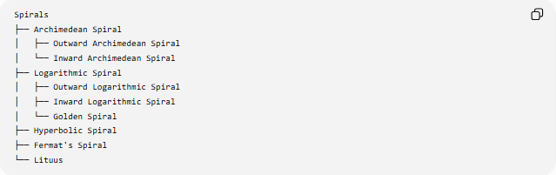
Spirals
├── Archimedean Spiral
│ ├── Outward Archimedean Spiral
│ └── Inward Archimedean Spiral
├── Logarithmic Spiral
│ ├── Outward Logarithmic Spiral
│ ├── Inward Logarithmic Spiral
│ └── Golden Spiral
├── Hyperbolic Spiral
├── Fermat's Spiral
└── Lituus
Outward and inward Logarithmic Spiral describe the direction of radial change. The Golden Spiral is a specific logarithmic spiral determined by the golden ratio.

Key Points
# Source: AI Source: Provided by: [Data Path: Persons Table -> ID Column: 1, Name_En Column: Motasem Essam] -> From: [ChatGPT] on [7/25/2026]
- A Logarithmic Spiral has the equation:
$$\boxed{r=ae^{bθ}}$$
- Its radius changes exponentially with angle.
- Its logarithmic form is:
$$\boxed{\ln{r}=\ln{a}+bθ}$$
- Its radial derivative is:
$$\boxed{\frac{dr}{dθ}=br}$$
- Equal angular intervals produce equal multiplicative changes in radius.
- After one complete turn:
$$\boxed{\frac{r\left(θ+2π\right)}{r\left(θ\right)}=e^{2πb}}$$
- It is an equiangular spiral.
- $b>0$gives outward growth.
- $b<0$gives inward growth.
- The Golden Spiral is a special logarithmic spiral associated with the golden ratio.

Conclusion
# Source: AI Source: Provided by: [Data Path: Persons Table -> ID Column: 1, Name_En Column: Motasem Essam] -> From: [ChatGPT] on [7/25/2026]
A Logarithmic Spiral is a spiral whose radial distance changes exponentially with its angular position:
$$\boxed{r=ae^{bθ}}$$
Its defining characteristics are exponential radial growth or decay, a constant radial ratio for equal angular intervals, and its equiangular property, meaning that the angle between the spiral and the radial direction remains constant.
Unlike the Archimedean Spiral, which has constant spacing between turns, the Logarithmic Spiral has changing spacing between turns while maintaining the same geometric growth pattern. The Golden Spiral is a special logarithmic spiral whose growth is related to the golden ratio.

